INTRODUCTION TO JENKINS AND CI/CD

WHAT IS CI-CD
ci/cd is a process of continuously delivering the application to the customer by introducing the automation on every stage of sdlc lifecycle
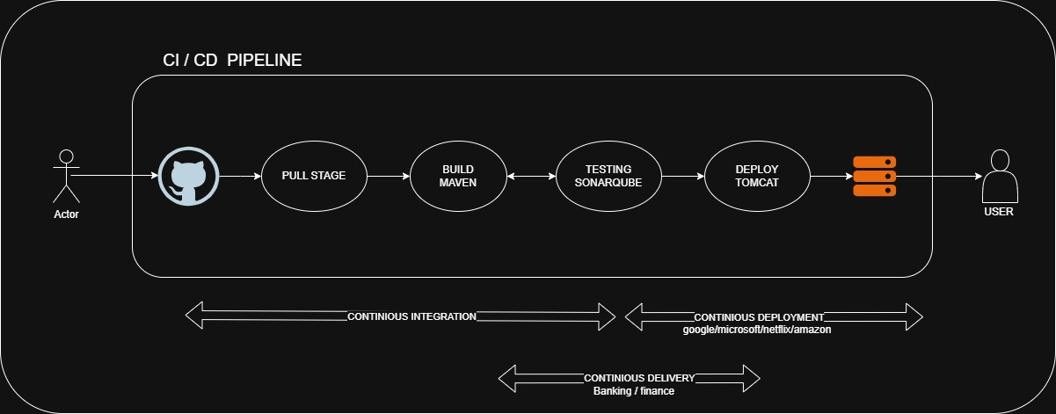
EXPLANATION TO CI/CD
1.CONTINIOUS INTEGRATION
Continuous Integration is the practice where developers frequently commit code to a shared repository (like GitHub), and each commit is automatically:
- Pulled by Jenkins
- Built using Apache Maven
- Tested using SonarQube
- Continuous feedback
- developer
CI ensures that code is always integrated, tested, and error-free early
In CI, developers write code and push it to GitHub. A CI tool like Jenkins automatically pulls the code, builds it using Apache Maven, and checks code quality with SonarQube. This process runs automatically whenever new code is committed, helping to find issues early and maintain code quality.
Pipeline Flow
Developer → GitHub → Build → Test → SonarQube → Artifact

2.CONTINIOUS DEPLOYMENT
- After successful testing, code is automatically deployed to production
- No human intervention
- Used in Tech companies like Google, Netflix, Microsoft
Every successful change goes live automatically
After the code is successfully tested in the CI pipeline, it is automatically pushed to the production environment and deployed to the server without manual intervention. This automated process of releasing and deploying code changes is called Continuous Deployment (CD).
Pipeline Flow
Developer → GitHub → Build → Test → Auto Deploy to Production
3.CONTINIOUS DELIVERY
- Continuous Delivery means the application is Built, Tested, Ready for deployment
- But deployment to production requires manual approval
- Used in Banking, Finance, Secure environments
Code is always ready to release, but humans decide when…
This approach is commonly used in banking, finance, and other secure environments, where security and compliance are critical. Human experts review the code, test results, and security checks to ensure there are no bugs, vulnerabilities, or policy violations before approving the release.
Pipeline-Flow
Developer → GitHub → Build → Test → Security Checks → Manual Approval → Production Deployment

JENKINS
Jenkins is free and open-source automation server that helps us to automate the entire sdlc lifecycle stages like building, testing and deployment.
History of Jenkins
- jenkins was originally called Hudson
- created by kohsuke Kawaguchi in 2004
- Developed by sun Microsystems.
- Later oracle corporation acquired the sun microsystems
- Due to conflicts with Oracle, Hudson was renamed to Jenkins in 2011
"Hudson was renamed Jenkins, but the purpose remained the same — automation."
Advantages of Jenkins
- Automation – Automates build, test, and deployment
- Plugin Support – Thousands of plugins available
- Continuous Integration – Helps integrate code frequently
- Open Source – Free to use and customizable
- Faster Delivery – Speeds up development lifecycle

INSTALLATION OF JENKINS
1.create a server (ubuntu)
2.access the server
- sudo apt update
- sudo apt install fontconfig openjdk-21-jre
- java --version
- Install long-term support package
sudo wget -O /etc/apt/keyrings/jenkins-keyring.asc \
https://pkg.jenkins.io/debian-stable/jenkins.io-2026.key
echo "deb [signed-by=/etc/apt/keyrings/jenkins-keyring.asc]" \
https://pkg.jenkins.io/debian-stable binary/ | sudo tee \
/etc/apt/sources.list.d/jenkins.list > /dev/null
- sudo apt update
- sudo apt install Jenkins
- jenkins --version
3.Access the Jenkins server
< public_ip:8080 >

